Summer/Fall 2018
What | Date | Time | Place
SHE Walks | June 9th | 9:30-11:30 AM | Oxbow Park
SHE Walks | July 14th  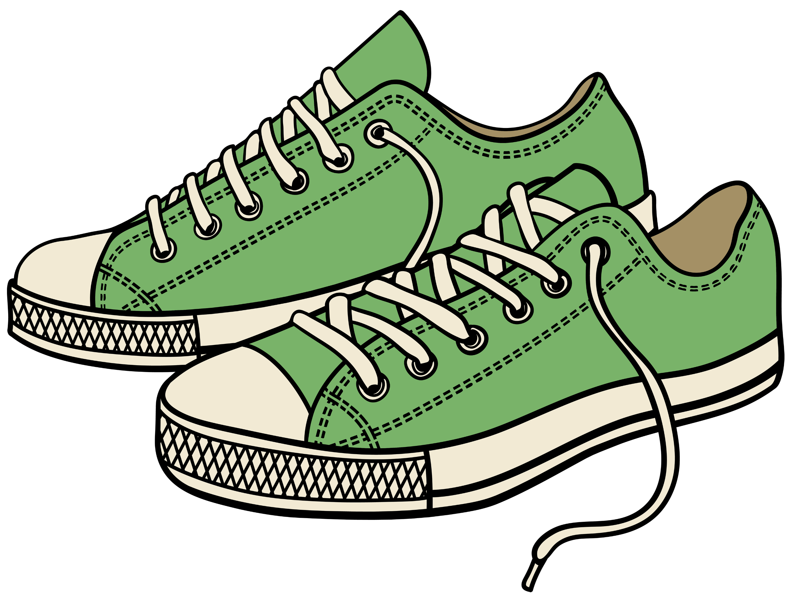 | 9:30-11:30 AM | Quarry Hill
SHE Walks | August 11th | 9:30-11:30 AM | Carley State Park
SHE Retreat | Sept. 14th – 16th | Fri. 6:30 PM – Sun. 2:00 PM | Eagle Bluff Nature Center
SHE is Captivating | September 25th | 6:30 – 8:00 PM | Crosswinds
SHE is Captivating | October 23rd | 6:30 – 8:00 PM | Crosswinds
Canvas & | November 9th | TBD | Crosswinds
SHE is Captivating | November 27th | 6:30 – 8:00 PM | Crosswinds

