
Middle School and High School
Sept. – Dec. 2023 Calendar
6:00 PM – 7:30 PM
September
17th Golden Goose Chase 4:30-7:00 PM Cost $20.00
Dinner included

24rd Student Impact Eye 2 Eye

October

1st Small Groups

8th Student Impact Eye 2 Eye
Parents Night

15th Small Groups

22nd MEA WEEKEND (Student Ministries Off)

29th FALL CELEBRATION

November
5th Student Impact Eye 2 Eye

10-11th Reality Conference Edina Cost $160.00

19th Student Impact The Edge!

26th Thanks Giving Break

December
3rd Student Impact The Edge!

10th Christmas Celebration

23rd Christmas Break (Dec. 24-31, 2023)

Special Event Information on back

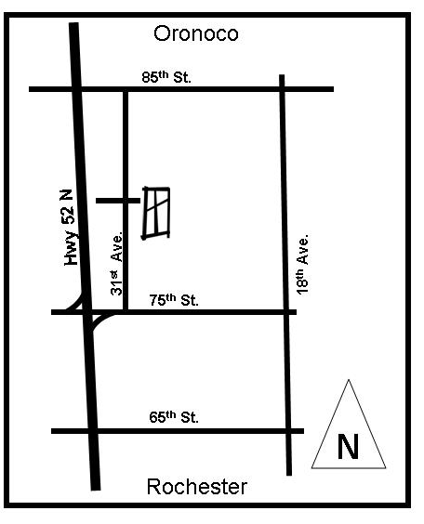
Program Info

Golden Goose Chase – The student ministries kickoff event. It is a road rally, scavenger hunt searching for a golden goose. After the race students will hang out for dinner.

Parents Night – Wonder what we do? Come find out first hand. We will walk you thru an evening at Student Impact. Information will be given out for the summer 2024 mission trip to Mexico.

Small Groups - Places where students hang-out, build friendships and have an opportunity to explore spiritual questions with students in their grade.

Student Impact – Our middle school and Sr. high will meet together for a worship service that features, drama, video, worship and teaching. We are starting the year with the series “Eye 2 Eye”

Fall Celebration – Opportunity for students to hang out, play games, and invite friends.

Reality Conference – This is an apologetics conference at Grace Church in Eden Prairie. The goal is to help students defend their faith and interact with students and adults that have different world views. We stay at a hotel in Eden Prairie on Friday night.



For More info contact:
Doug Weincouff
398-8112
Doug.Weincouff@crosswindschurch.com
Check Us Out:
crosswindschurch.com/youth

